# Introduction

During this group assignment a flight booking system will be produced. The system will be developed for the customer in the form of an on-line system where customers can enter their personal details to search for flights and return a price for the customer depending on destination and frequent flyer details. There will also be an option where the administrator can log in to the system where customer details can be viewed and edited.

This system will be developed by a team that will make use of some enterprise applications to aid in the development process. The applications are as follows: GitHub, Jira, and Javadocs. The system will be developed using agile methodologies and will comprise of several sprints of 1-2 weeks. The team will carry out scrum meetings weekly to communicate tasks that are completed, upcoming and how everyone is getting on with the development.

# Planning

The team had meetings twice a week. One meeting was held in class and this is where the team had their weekly scrum. The second meeting was out of class and usually in a library study room. In these weekly meeting the team discussed the tasks completed, upcoming tasks, and any issues that were encountered during the past week. Jira was used to outline the tasks and to assign tasks to the team members.

## 2.1 Development Environment

|  |  |
| --- | --- |
| Tools Used | Version |
| Eclipse | Oxygen |
| MySQL Database | AWS RDS |
| MySQL Workbench | 6.2 |
| Jira | 7.6.1 |
| XAMPP | 7.1.12 |
| GitHub & Git | 2.15.1 |
|  |  |
|  |  |

# Design of the System

## Designing the system at team meetings

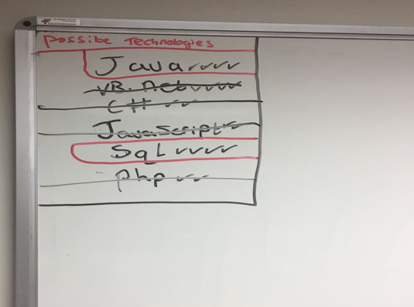

*Fig 3.1 – Possible Technologies*

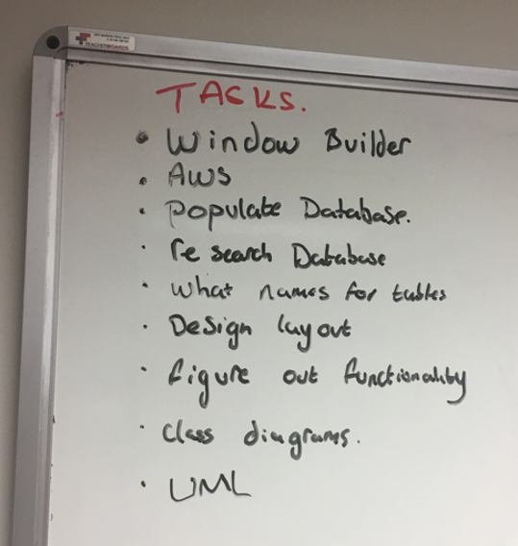

*Fig 3.2 – Tasks to complete the project*

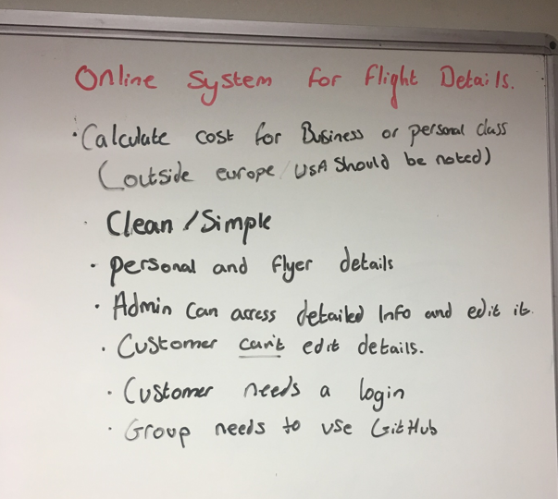

*Fig 3.3 – Group requirements*

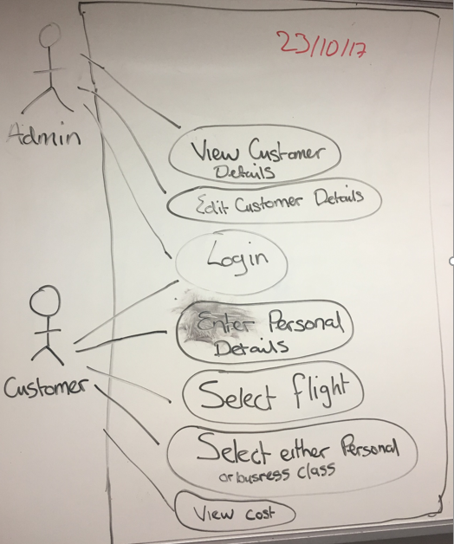

*Fig 3.4 – UML Use Case Diagram*

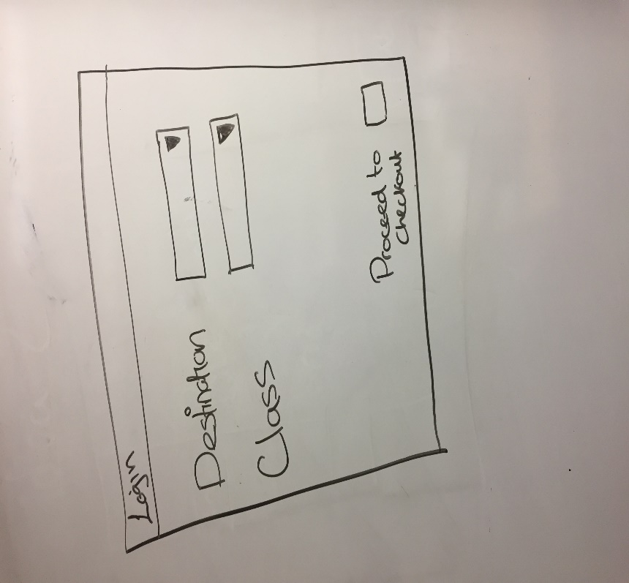

*Fig 3.5 – Customer Login Window*

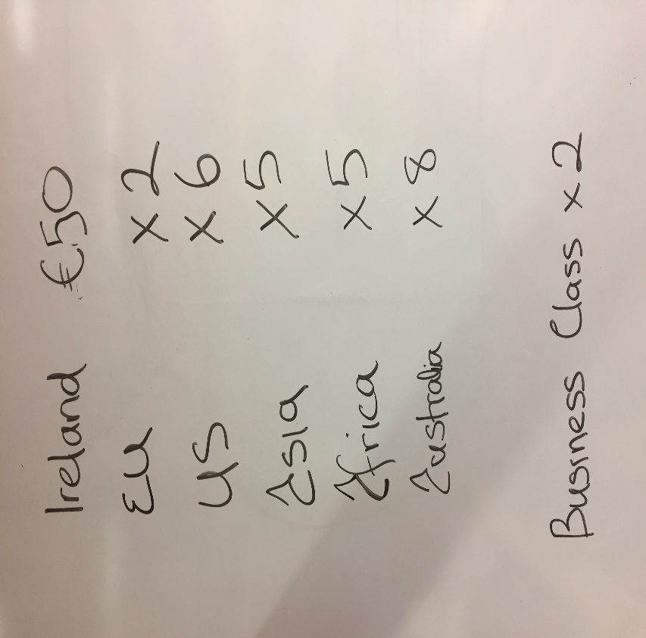

*Fig 3.6 – Costings for Travel Destinations*

## 3.2 Class Diagram

# 

# Use Case Descriptions

## 4.1 Register Client

|  |  |
| --- | --- |
| Use Case | Register Client |
| Objective | To register a client on the system |
| Precondition | The client wishes to register their details on the system. |
| Main Flow | 1. Client enters details. (Name, Address, DOB, Contact Details) 2. Client registers on system. |
| Alternative Flow |  |
| Post Condition | 1. Client has been registered. |

## 4.2 Select Flight

|  |  |
| --- | --- |
| Use Case | Select flight. |
| Objective | To select a flight. |
| Precondition | A client wishes to select a flight and view the cost. |
| Main Flow | 1. Client logs in. 2. Client views available flights. 3. Client selects flight. 4. Client selects business or personal class. 5. Client views cost. |
| Alternative Flow | 1. No log in details, see use case register client. |
| Post Condition | A client has selected a flight and viewed the cost of the flight. |

## 4.3 Edit Flight Details

|  |  |
| --- | --- |
| Use Case | Edit Flight Details |
| Objective | To edit flight details |
| Precondition | The administrator wishes to edit flight details on the system. |
| Main Flow | 1. Administrator logs in 2. Administrator edits flight details. |
| Alternative Flow |  |
| Post Condition | 1. Administrator has edited flight details. |

## 4.4 Edit Client Details

|  |  |
| --- | --- |
| Use Case | Edit Client Details |
| Objective | To edit client details on the system |
| Precondition | The administrator wishes to edit client details |
| Main Flow | 1. Administrator logs in. 2. Administrator edits client details |
| Alternative Flow |  |
| Post Condition | 1. Administrator has edited client details. |

# Requirements

The requirements for this flight booking system are as follows:

## 5.1 Functional Requirements

### Administrator

* Log in to System
* View Client Details
* Edit Client Details
* View Flight Details
* Edit Flight Details

### User

* Register
* Log In
* View Available Flights
* Select Flight
* Select Business or Personal Class
* View Cost of Flight

## 5.2 Non-Functional Requirements

### Availability

* The system should be 99.999% available.

### Security

* The system should only be available to registered users
* Passwords must contain numbers and letters and at least one capital letter.
* Users will have three attempts to login after which they will be locked out of the system.
* Once the client enters details it should not be able to be changed by the client.

### Confidentiality

* Only the administrator may view the other client’s details.

### Usability

* The system shall be easy to use by people without training.

# Review of Existing Systems

This section samples an existing system which serves a similar purpose to the system we have been assigned for our team project. It has been examined to so that we can create our own GUI that works in a similarly efficient way.

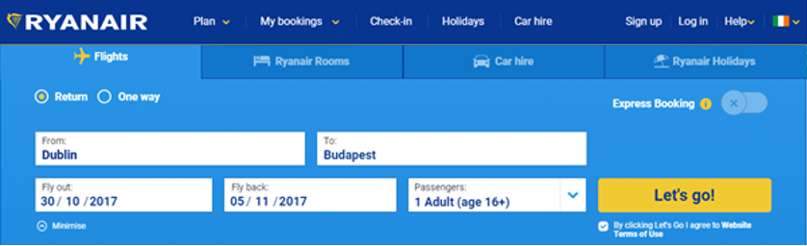

*Fig 6.1 - Ryanair’s Initial Menu*

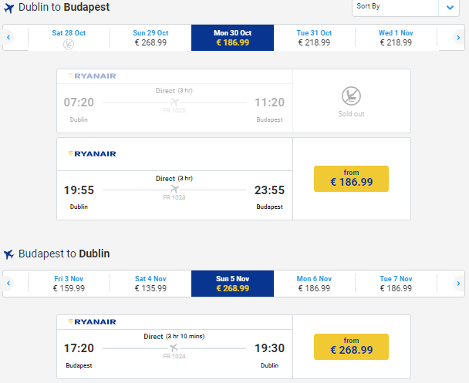

*Fig 6.2 - Price for flight(s) displayed*

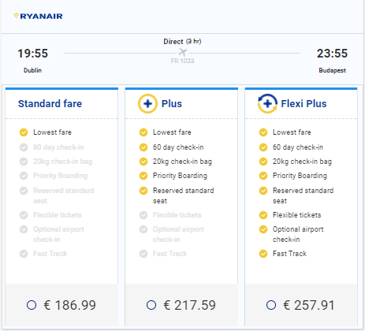

*Fig 6.3 - Additional options displayed*



*Fig 6.4 - Cost displayed with no user login required*

Our system will be developed in Java using eclipse. The GUI above can be similarly represented on a Java GUI platform as the Java components that exist are quite similar to this web based system’s components (e.g. JButton, JTextfield, JCheckBox, JDialog, JRadioButton etc.).

# DevOps Development Tools

## 7.1 Jira

Jira is a software development tool used for agile development. The team used this tool to create sprints that last one week at a time. Inside the sprints are a list of tasks that the team wish to have completed within the sprint. Tasks are assigned to team members and are then marked as done once they are completed.

# 

*Fig 7.7.1 Jira Backlog*

## 7.2 Javadoc

Javadoc is a tool which comes with the Java Development Kit which is used to generate documentation from Java source code in html format. This makes it easier for other users and developers to see the classes, methods and parameters/returns and what they are coded for. Below are examples from our project of how the code is generated and the html format when generated.

# 

*Figure 7.2.1 Example of JavaDoc comments which generate Javadoc*

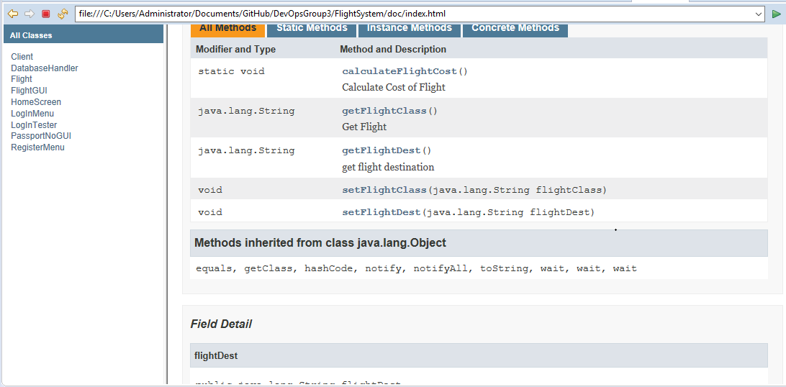

*Figure 7.2.2 Java Documentation after generation*

## GitHub

The team used GitHub for version control when building the system. Every time a change was made to the system code or the assignment document, it was uploaded onto GitHub.

## 

*Fig 7.3.1 Team GitHub Repository*

# Database

A MySQL database is used for this system. This database was stored on the AWS cloud.

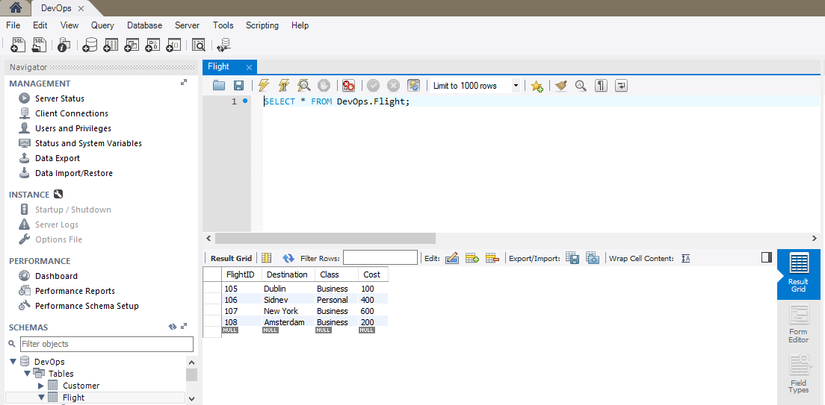

*Fig 8.1 MySQL Database – Flight Class*

## 8.1 Database ERD

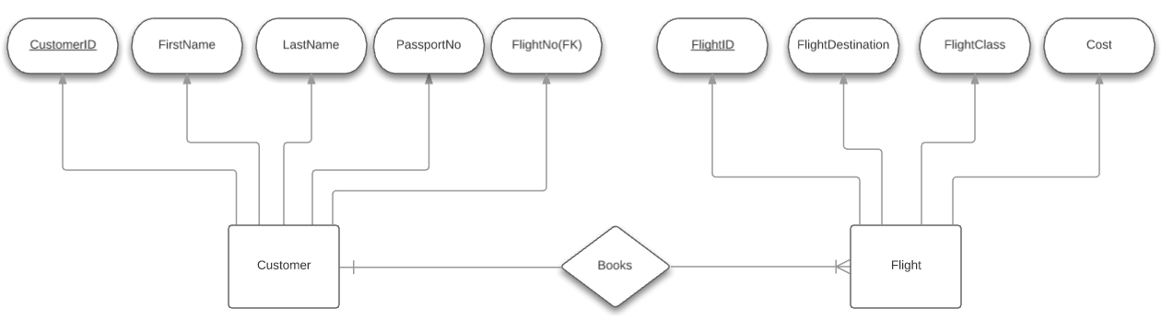

*Figure 8.1.1 ERD for System*

# Contract Change

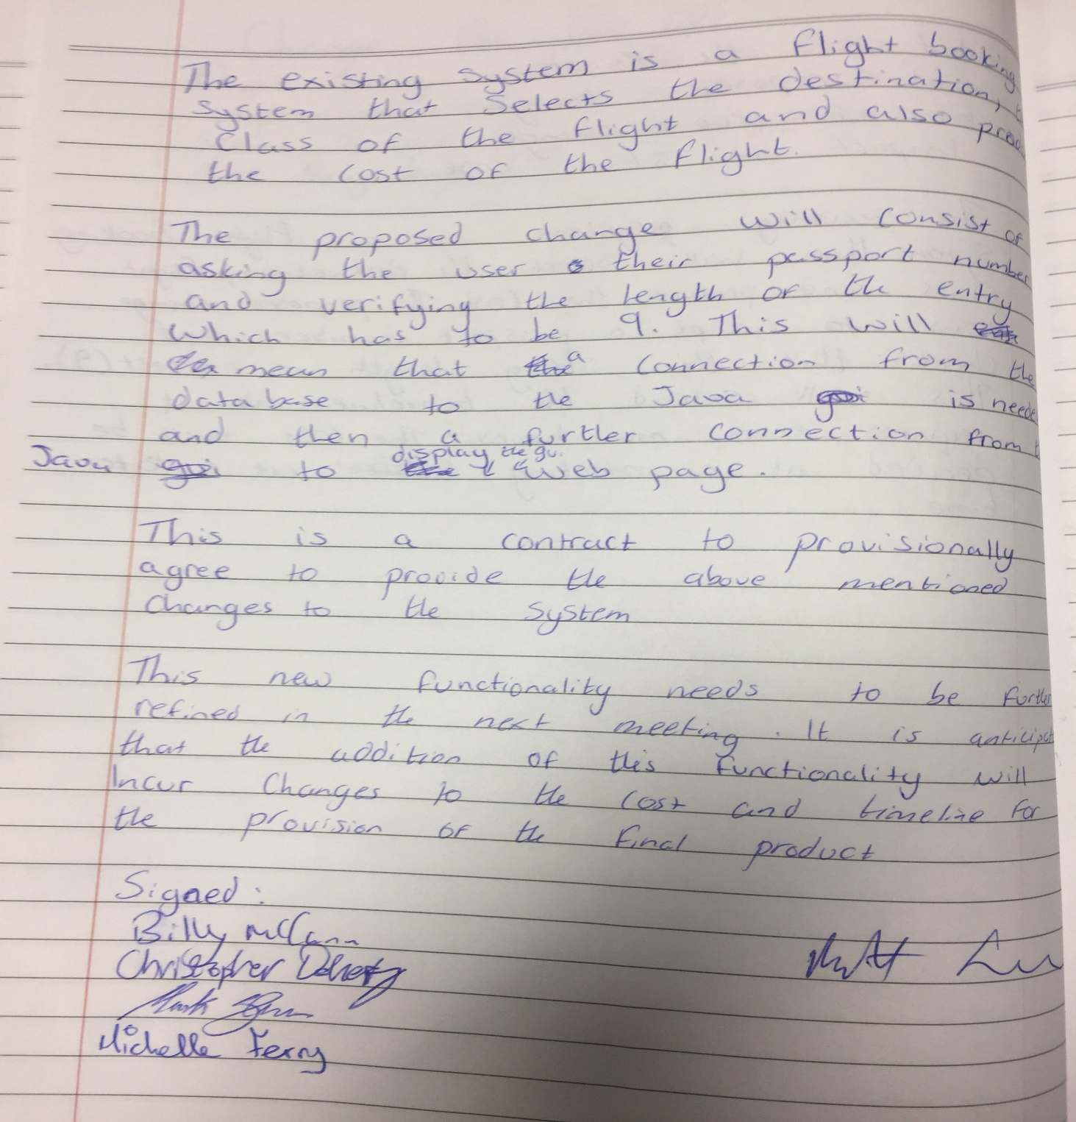

# Individual Conclusions

### Michelle Ferry

### Mark Glen

The DevOps module was a useful introduction into the various tools used such as Jira, GitHub, Jenkins, Maven and Selenium which help teams to collaborate, test and organise their projects efficiently. The team project was very interesting but was also a learning curve in regards to working with a team who don’t see each other out of class and so tools such as Jira, GitHub and the scrum meetings were a necessity to keep track of what was going on in the development of the system.

Unfortunately, this module was only assigned three hours of classes a week which was a shame as DevOPs and the tools it involves could be extremely useful upon entering the workforce after graduation and I would have enjoyed the chance to learn these tools more comprehensively.

In regards to the team project, the team did not have time to integrate JUnit testing into the project which was disappointing as testing is an important part of any system development. GitHub pushes were mainly done from one laptop which was not the correct way to do things as every student should have had a working system and been able to push to the GitHub as well as commit to their own local Git repository. The team also had the web page interacting with the database via php which was not the solution required as we should have had it interacting with the Java (Restful API) with the Java making requests to the database.

Despite these setbacks I learned a lot from the module and although things didn’t go to plan, I know where I went wrong and what should be done differently next time. The main positive I would take from this module is that I got a good introduction into some of the various tools DevOps teams use and would be able to have a conversation about them in an interview which will be extremely useful upon graduation.

### Christopher Doherty

This project encouraged the use of many software development tools such Jira, GitHub and Javadoc. Along with using these tools, agile development methodologies were applied throughout the development process. The team had a one-hour weekly meeting. Meetings were held in the form of SCRUM meetings. Tasks for the coming week were identified and allocated to a team member. These tasks were then documented and updated accordingly using Jira in the form of a sprint. Any tasks which could not be completed for that week were then placed either in the next weekly sprint or put into the product backlog for a later date. Any new code or additions to the word document were pushed onto GitHub so as to ensure that the team as a whole were always working on the latest version of project. GitHub could have perhaps been use more frequently, but at the end of the project’s development this tool is much more understood and its practicality realised. Javadoc was generated alongside the Java programs in eclipse so that an API was easily generated upon completion of the project. Unfortunately we were unable to include a testing technique such as JUnit testing to make our system more robust and reliable due to time constraints, but its exclusion highlighted the importance of testing for developing any software artefact.

This project challenged our team to deliver a system using a collaborative approach that utilised useful software development tools in an agile manner. This project tasked us with an additional feature late in development (this helped us greatly in understanding the importance of the development tools we used), that asks the user for their passport number in the Java GUI and once received, the Java code would open the PC’s default web browser and display their passport number and booking details. This additional feature was originally programmed using JSP but I had an issue with updating the passport number, so PHP was used to achieve a solution as I have prior experience with PHP. Having worked as part of an agile team to deliver this software artefact, skills have been developed that will prove beneficial for job interviews where the company promotes agile software development and the use of software development tools.

### Billy McCann

I found this group project very rewarding and also beneficial for later use in work life. We were asked to create a flight system that would allow the user to select a destination and also what class they would be flying in. Even though our group were one of the smallest in terms of members I felt that we had a great work ethic between the 4 of us and that we divided our work well and developed a great plan for the completion of our project. Personally, I felt that I could have added more functionality to my part of java. In the register page I could have added error handling to stop users entering number in the first and second name sections. Our group worked very well together. Each person expressed their ideas and none of them were metwith negativity.  There was a constant open line of communication via email, which we all utilized. On the day of our presentation, we all played a vital role. We all arrived early to set up.  During the weekly meetings every member took their turn to suggest how to move forward and we all decided what to do in the week that followed. Overall I felt our team worked very well and that our final project done what was asked of it.